**<>**

**-SIIF-**

-Versión 1.0-

# Revision History

|  |  |  |  |
| --- | --- | --- | --- |
| Date | Version | Description | Author |
| 2019/06/01 | 1.0 | Base de datos SIIF | Sebastián López |
|  |  | SISTEMA DE INFORMACIÓN DE INVENTARIOS FARMACEUTICOS | Jeisson Silva |
|  |  |  | Camilo Quintero |

# Table of Contents

Revision History 2

Table of Contents 3

Introduction 4

Purpose 4

Scope 4

Definition, Acronyms and Abbreviations 4

References 4

Database Design 4

Data Dictionary 4

Appendices 4

# Database Design

## Entity Relationship Diagram

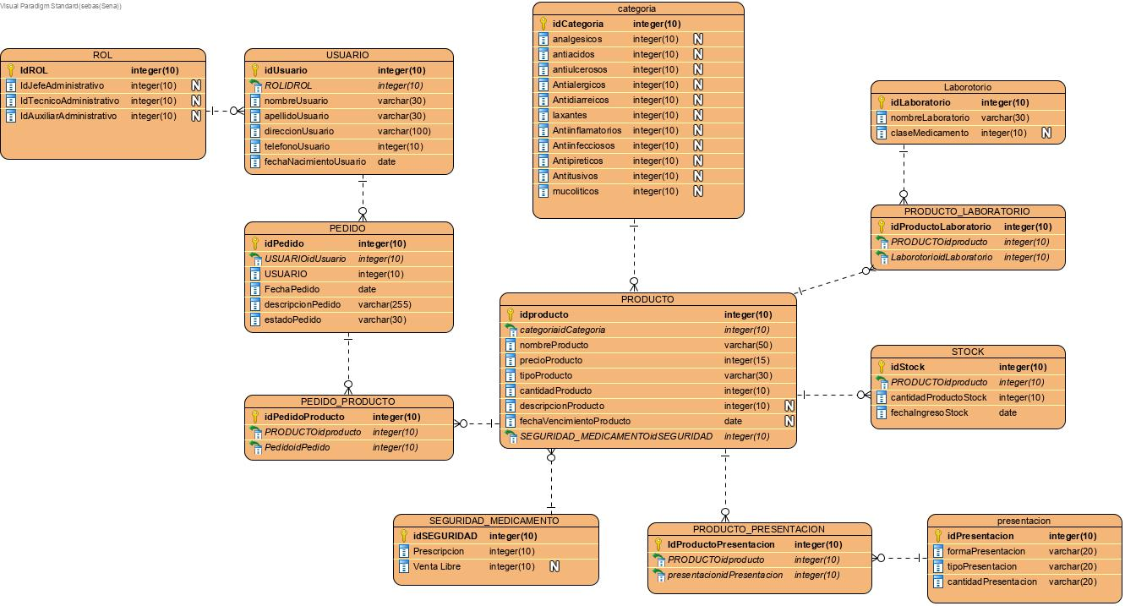

# Data Dictionary

## Data Dictionary

|  |  |  |  |  |  |  |  |  |  |
| --- | --- | --- | --- | --- | --- | --- | --- | --- | --- |
| Entity Name | Entity Description | |  |  |  |  |  |  |  | | --- | --- | --- | --- | --- | --- | --- | | Column Name | Column Description | Data Type | Length | Primary Key | Nullable | Unique | |
| categoria | Cada producto tiene una diferente categoría | | analgésicos |  | integer | 10 | false | true | false | | --- | --- | --- | --- | --- | --- | --- | | antiácidos |  | integer | 10 | false | true | false | | Antialérgicos |  | integer | 10 | false | true | false | | Antidiarreicos |  | integer | 10 | false | true | false | | Antiinfecciosos |  | integer | 10 | false | true | false | | Antiinflamatorios |  | integer | 10 | false | true | false | | Antipiréticos |  | integer | 10 | false | true | false | | Antitusivos |  | integer | 10 | false | true | false | | antiulcerosos |  | integer | 10 | false | true | false | | idCategoria |  | integer | 10 | true | false | false | | laxantes |  | integer | 10 | false | true | false | | mucolíticos |  | integer | 10 | false | true | false | |
| Laborotorio | Cada producto tiene un laboratorio de origen | | claseMedicamento |  | integer | 10 | false | true | false | | --- | --- | --- | --- | --- | --- | --- | | idLaboratorio |  | integer | 10 | true | false | false | | nombreLaboratorio |  | varchar | 30 | false | false | false | |
| PEDIDO | Los productos son seleccionados a través de un pedido | | descripcionPedido |  | varchar | 255 | false | false | false | | --- | --- | --- | --- | --- | --- | --- | | estadoPedido |  | varchar | 30 | false | false | false | | FechaPedido |  | date | 0 | false | false | false | | idPedido |  | integer | 10 | true | false | false | | USUARIO |  | integer | 10 | false | false | false | | USUARIOidUsuario |  | integer | 10 | false | false | false | |
| PEDIDO_PRODUCTO |  | | idPedidoProducto |  | integer | 10 | true | false | false | | --- | --- | --- | --- | --- | --- | --- | | PedidoidPedido |  | integer | 10 | false | false | false | | PRODUCTOidproducto |  | integer | 10 | false | false | false | |
| presentación | Cada producto tiene su presentación es decir su forma y una | | cantidadPresentacion |  | varchar | 20 | false | false | false | | --- | --- | --- | --- | --- | --- | --- | | formaPresentacion |  | varchar | 20 | false | false | false | | idPresentacion |  | integer | 10 | true | false | false | | tipoPresentacion |  | varchar | 20 | false | false | false | |
| PRODUCTO |  | | cantidadProducto |  | integer | 10 | false | false | false | | --- | --- | --- | --- | --- | --- | --- | | categoriaidCategoria |  | integer | 10 | false | false | false | | descripcionProducto |  | integer | 10 | false | true | false | | fechaVencimientoProducto |  | date | 0 | false | true | false | | idproducto |  | integer | 10 | true | false | false | | nombreProducto |  | varchar | 50 | false | false | false | | precioProducto |  | integer | 15 | false | false | false | | SEGURIDAD_MEDICAMENTOidSEGURIDAD |  | integer | 10 | false | false | false | | tipoProducto |  | varchar | 30 | false | false | false | |
| PRODUCTO_LABORATORIO |  | | idProductoLaboratorio |  | integer | 10 | true | false | false | | --- | --- | --- | --- | --- | --- | --- | | LaborotorioidLaboratorio |  | integer | 10 | false | false | false | | PRODUCTOidproducto |  | integer | 10 | false | false | false | |
| PRODUCTO_PRESENTACION |  | | IdProductoPresentacion |  | integer | 10 | true | false | false | | --- | --- | --- | --- | --- | --- | --- | | presentacionidPresentacion |  | integer | 10 | false | false | false | | PRODUCTOidproducto |  | integer | 10 | false | false | false | |
| ROL |  | | IdAuxiliarAdministrativo |  | integer | 10 | false | true | false | | --- | --- | --- | --- | --- | --- | --- | | IdJefeAdministrativo |  | integer | 10 | false | true | false | | IdROL |  | integer | 10 | true | false | false | | IdTecnicoAdministrativo |  | integer | 10 | false | true | false | |
| SEGURIDAD_MEDICAMENTO |  | | idSEGURIDAD |  | integer | 10 | true | false | false | | --- | --- | --- | --- | --- | --- | --- | | nombre |  | integer | 10 | false | false | false | |
| STOCK |  | | cantidadProductoStock |  | integer | 10 | false | false | false | | --- | --- | --- | --- | --- | --- | --- | | fechaIngresoStock |  | date | 0 | false | false | false | | idStock |  | integer | 10 | true | false | false | | PRODUCTOidproducto |  | integer | 10 | false | false | false | |
| USUARIO |  | | apellidoUsuario |  | varchar | 30 | false | false | false | | --- | --- | --- | --- | --- | --- | --- | | direccionUsuario |  | varchar | 100 | false | false | false | | fechaNacimientoUsuario |  | date | 0 | false | false | false | | idUsuario |  | integer | 10 | true | false | false | | nombreUsuario |  | varchar | 30 | false | false | false | | ROLIDROL |  | integer | 10 | false | false | false | | telefonoUsuario |  | integer | 10 | false | false | false | |

# Appendices